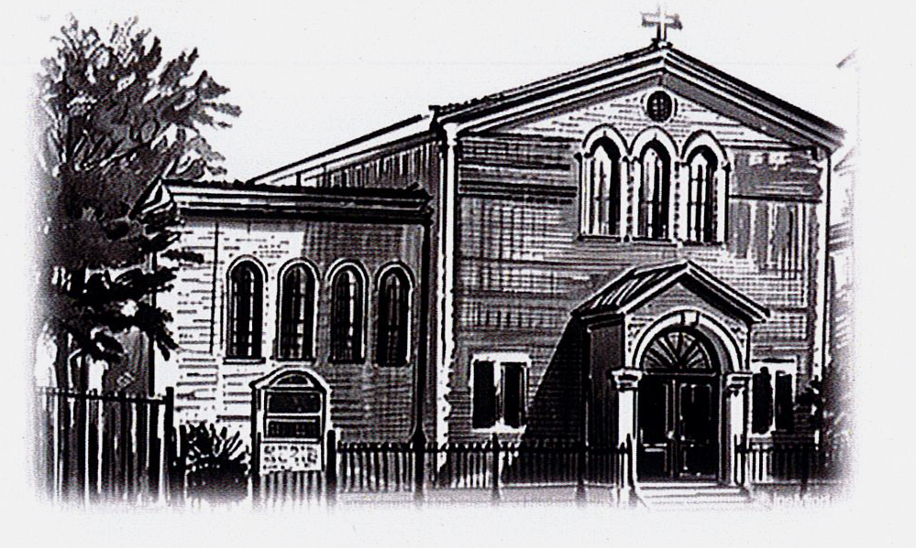**ST PETER APOSTLE CHURCH, RUSHDEN**

Parish Priest: Rev Dariusz Bialowas

Tel: 01933 353649

Deacon: Rev Peter Remmington

Parish Secretary: Charmaine: Tue to Thu: 10am - 2pm Parish Safeguarding Representative: Stuart Pearce

Email: [parish.stpeterrushden@northamptondiocese.org](mailto:parish.stpeterrushden@northamptondiocese.org)

Website: [https://rushdencatholicchurch.co.uk/](https://rushdencatholicchurch.co.uk/index.php/weekly-newsletter/)

Twitter:  [www.twitter.com/rushdencatholic](http://www.twitter.com/catholicrushden)

Facebook: [www.facebook.com/StPeterApostle](http://www.facebook.com/StPeterApostle)

churchRushden

**29th June 2025 – YEAR C**

**FEAST OF ST PETER AND ST PAUL, APOSTLES**

**PREFACE:** The Two Fold Mission

**EUCHARISTIC PRAYER**: Number 3

**MYSTERY OF FAITH:** We proclaim your death …

**Sat:** 6:30pm - Special Intention

**Sun:** 10:00am - People of St Peter’s living and deceased

**Tue:** 10:00am - Special Intention

**Wed:**  7:00pm - Mary Miller RIP

**Thu:** 10:00am - Lilly Riddle RIP

**Fri:** 12 noon - Private Intention

**Sat:** 6:30pm - People of St Peter’s living and deceased

**Sun:** 10:00am - Enrico Panarella RIP

Rosary: Wednesday 6:30pm

Holy Hour, Exposition of the Blessed Sacrament and

Confession Friday 11am

**Please pray for those whose anniversaries occur at this time:** Henry Spring, John Rooney, Alice Maker, Francis Giff, Maureen Perez, Samuel Brader, Christine Murphy, Mary Johnston, Enrico Panarella, Hannah Hurley, Fanny Rowthorn, James O’Halloran, Margaret Cox, Charlotte & Frances Oatridge, Leslie Lopez, Salvatore Tramacere, Wilfred Newell, Patricia Beeby, Thomas Farrelly, Arthur Cross, Andrew Dorney, Annette Bishop, Elizabeth Whittaker, Margaret Packwood, and Elizabeth Tricker.

**Please Remember in Prayer**, Eileen Bishop, Amber, the Collett family, the Boothby family, Gary, Margery, Inge, Vanessa, Merin, Isabel, Alfin, Annie, Jean, Linda, Kevin Barker, Stephen, the Cudone family, Yvonne, Nathan, Sophie, Kele, Luna, Samantha, Lewis, Irene, Rosa Velez Reboredo, Derek, John, Philip, Halina, Laeress, Joseph & Sneba, Caroline, Jenny, Amy, Matthew Pu, Achu, Rita, Malia, Emma, Eva, Olivia, Linda, Susan Allen and Ida.

**OFFERTORY:**  Last week’s collection amounted to £670.98. Thank you all very much for your kind contributions to the parish.

**SECOND COLLECTION:** This weekend is for Peter’s Pence.

**CHILDREN’S LITURGY:** Is available to all children aged 5-11 years old at the 10am Mass. We invite the children to come out to the hall/lounge after the entrance hymn and we return them at the Offertory.

**BISHOP’S VISITATION:** A very warm welcome to Bishop David who is visiting the parish this weekend and will celebrate the two weekend Masses. We hope to have teas & coffees and light refreshments in the hall after both Masses. It would be lovely if everyone could make the effort to go into the hall afterwards to make Bishop David feel welcome.

**THE CHILDREN’S ROSARY PRAYER GROUP:** Will meet on Saturday July 5th at 10:30am in Church.

**COFFEE MORNING:** On Saturday July 5th from 10am to 12 noon there will be a Coffee Morning in the Parish Hall for Church funds so please support this. There will be a raffle. If you can give a prize or prizes for the raffle that will be much appreciated. Please bring raffle items on the day, thank you.

**YOUR SYMPATHY:** Is requested for the family and friends of Maria Girardi who died on June 14th. Her funeral Mass will be held in Church on Wednesday July 9th at 10:30am followed by burial at Rushden cemetery.

**SVP WALSINGHAM PILGRIMAGE** - **SUNDAY JULY 6th:** The coach will leave at 8.50am prompt from the bus stop outside Church returning around 7pm. Any problems on the day, please ring James on 07785 285003.

**LIVING FAITH:** Daily scripture reflection magazine for July to September now available in Church, priced £1:50.

**UCM:** The next UCM meeting will be on Wednesday July 16th after Mass at approximately 8pm in the Parish Hall. There will be a talk by Vicky Thompson on their 3 days in Jerusalem with Fr Stan. All are welcome to attend this evening talk. Tea and coffee will be available.

**FOODBANK DONATIONS:** There is a comprehensive list of requested items at the back of Church (including tinned foods & household goods). Please keep the donations coming, as stocks are running low and demand is increasing more and more. Thanks to everyone for all the donations, both of goods and money!

**NATIONAL BOARD OF CATHOLIC WOMEN (NCBW):** Helen Burgess is the Northampton Diocese, Diocesan link for the National Board of Catholic Women (NBCW). Have you heard of this organisation? Do you think your parish has heard of it? Join us on line on July 8th at 7:30pm where Helen will interview the president of the NBCW, find out what's been happening, learn about this important Catholic Organisation and get involved! Find out more at: <https://www.nbcw.co.uk/> and for the Zoom link for July 8th contact <helen.burgess@northamptondiocese.org>. See poster on noticeboard.

**HELP REQUIRED:** The parish is looking for volunteer/s to help with small DIY jobs that need doing. If you think you can help please get in touch with the office.

**PARISH DATABASE WITH CASPAR:** Thank you to those that have already signed up to Caspar. If you would like to be included in the new St Peter’s parish database, the Parish Office can help between Tuesdays to Thursdays 10am - 2pm.

**POPE’S PRAYER INTENTION FOR JUNE:** "That the world might grow in compassion." Let us pray that each one of us might find consolation in a personal relationship with Jesus, and from His Heart, learn to have compassion on the world.