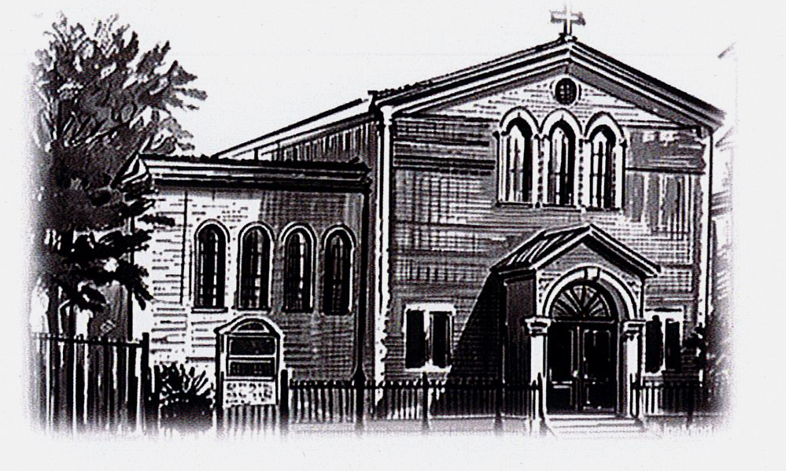**ST PETER APOSTLE CHURCH, RUSHDEN**

Parish Priest: Rev Dariusz Bialowas

Tel: 01933 353649

Deacon: Rev Peter Remmington

Parish Secretary: Charmaine: Tue to Thu: 10am - 2pm Parish Safeguarding Representative: Stuart Pearce

Email: [parish.stpeterrushden@northamptondiocese.org](mailto:parish.stpeterrushden@northamptondiocese.org)

Website: [https://rushdencatholicchurch.co.uk/](https://rushdencatholicchurch.co.uk/index.php/weekly-newsletter/)

Twitter:  [www.twitter.com/rushdencatholic](http://www.twitter.com/catholicrushden)

Facebook: [www.facebook.com/StPeterApostle](http://www.facebook.com/StPeterApostle)

churchRushden

**22nd JUNE 2025 – YEAR C**

**THE MOST HOLY BODY & BLOOD OF CHRIST**

**PREFACE:** Number 2

**EUCHARISTIC PRAYER**: Number 3

**MYSTERY OF FAITH:** When we eat this Bread…

**Sat:** 6:30pm - James Lavin RIP

**Sun:** 10:00am - Lucia Sacco RIP

**Tue:** 10:00am - Caroline Matthew intention

**Wed:**  7:00pm - James Miller RIP

**Thu:** 10:00am - Thanksgiving Mass

**Fri:** 12 noon - Enrico Panarella RIP

**Sat:** 6:30pm - Special Intention

**Sun:** 10:00am - People of St Peter’s living and deceased

Rosary: Wednesday 6:30pm

Holy Hour, Exposition of the Blessed Sacrament and

Confession Friday 11am

No Confession before 6:30pm Mass Saturday, June 21st

**Please pray for those whose anniversaries occur at this time:** Len Hennell, John Kinsella, Joan Swords, Frank McManus, Jimmy Lavin, Fr Peter Rogan, Teresa (Tess) Doran, Emma Cowley, Nora O’Halloran, Alotzy Gierzewski, Howard Hull, Anne Horn, Aldo Fanferma, Margaret Louizo, Daniel Tokarz, Patrick McGeever, Irene Lee, Thomas Duffy, Mary Woodward, Maria Prokopiuk, Elizabeth Richards, Bridget Doherty and Connie Murray.

**Please Remember in Prayer**, Judy, Carrie, Marcia, Diana, Mary, Marlėne, Bruce, Mimine, Neil, Fiona, Jemma, Eileen Bishop, Amber, the Collett family, the Boothby family, Gary, Margery, Inge, Vanessa, Merin, Isabel, Alfin, Annie, Jean, Linda, Emma, Eva, Olivia, Linda, Susan Allen, Kevin Barker, Stephen, the Cudone family, Yvonne, Nathan, Sophie, Kele, Luna, Samantha, Lewis, Irene, Rosa Velez Reboredo, Derek, John, Philip, Halina, Laeress, Joseph & Sneba, Caroline, Jenny, Amy and Matthew Pu.

**OFFERTORY:**  For the last week collection amounted to £553.56. Thank you all very much for your kind contributions to the parish.

**SECOND COLLECTION:** Last weekend raised £272 for Day for Life. Thank you very much.

**SECOND COLLECTION:** Next weekend is for Peter’s Pence.

**CHILDREN’S LITURGY:** Is available to all children aged 5-11 years old at the 10am Mass. We invite the children to come out to the hall/lounge after the entrance hymn and we return them at the Offertory.

**BISHOP’S VISITATION:** Bishop David will be visiting the parish next weekend, June 28th/29th. The Bishop will celebrate the two weekend Masses. We hope to have teas & coffees and light refreshments in the hall after both Masses. It would be lovely if everyone could make the effort to go into the hall afterwards to make Bishop David feel welcome.

**YOUR SYMPATHY:** Is requested for the family and friends of Maria Girardi who died on June 14th. Her funeral Mass will be held in Church on Wednesday July 9th at 10:30am followed by burial at Rushden cemetery.

**SVP WALSINGHAM PILGRIMAGE** - **SUNDAY JULY 6th:** The coach will leave at 8.50am prompt from the bus stop outside Church returning around 7pm. Any problems on the day, please ring James on 07785 285003.

**NOTRE DAME HIGH SCHOOL:** It is 50 years since the impressive Victorian building in Abington Street that was Notre Dame High School closed its doors for the last time and desks, books, pupils and teachers all moved to Thomas Becket School in Kettering Road. To mark this anniversary past pupils and teachers are invited to attend a Mass being celebrated in the Cathedral in Barrick Road on Saturday July 19th at 12 noon. Afterwards there will be refreshments in the St Thomas Centre next-door. There's no charge however a donation of £10 to help with the costs would be appreciated. For catering purposes please let Cathy Chaplin know that you'll be joining us on 07802 913124 or cathychaplin@hotmail.co.uk

**FOODBANK DONATIONS:** There is a comprehensive list of requested items at the back of Church (including tinned foods & household goods). Please keep the donations coming, as stocks are running low and demand is increasing more and more. Thanks to everyone for all the donations, both of goods and money!

**HELP REQUIRED:** The parish is looking for volunteer/s to help with small DIY jobs that need doing. If you think you can help please get in touch with the office.

**PARISH DATABASE WITH CASPAR:** Thank you to those that have already signed up to Caspar. If you would like to be included in the new St Peter’s parish database, the Parish Office can help between Tuesdays to Thursdays 10am - 2pm.

**POPE’S PRAYER INTENTION FOR JUNE:** "That the world might grow in compassion." Let us pray that each one of us might find consolation in a personal relationship with Jesus, and from His Heart, learn to have compassion on the world.

**Thought for the Day - Corpus Christi**

The moment of communion in Mass, when we eat the body of Christ and drink his blood, is the moment of greatest intimacy that can exist between Christ and us. However, we cannot be in communion with the Lord without being in communion with one another. As St Augustine used to remind the assembled congregation as he held up the Sacred Host: ‘See what you are and become what you see, the body of Christ’. That is the constant challenge of the Eucharist.