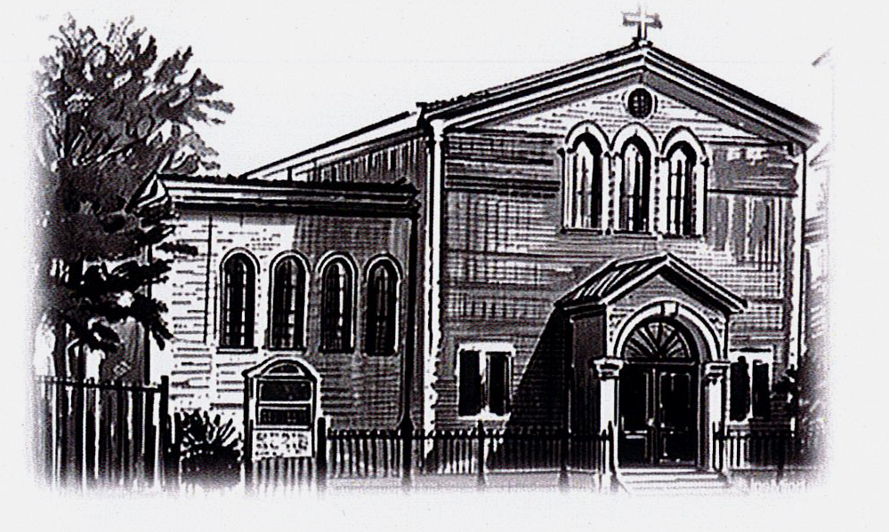**ST PETER APOSTLE CHURCH, RUSHDEN**

Parish Priest: Rev Dariusz Bialowas

Tel: 01933 353649

Deacon: Rev Peter Remmington

Parish Secretary: Charmaine: Tue to Thu: 10am - 2pm Parish Safeguarding Representative: Stuart Pearce

Email: [parish.stpeterrushden@northamptondiocese.org](mailto:parish.stpeterrushden@northamptondiocese.org)

Website: [https://rushdencatholicchurch.co.uk/](https://rushdencatholicchurch.co.uk/index.php/weekly-newsletter/)

Twitter:  [www.twitter.com/rushdencatholic](http://www.twitter.com/catholicrushden)

Facebook: [www.facebook.com/StPeterApostle](http://www.facebook.com/StPeterApostle)

churchRushden

**15th JUNE 2025 – YEAR C**

**THE MOST HOLY TRINITY**

**PREFACE:** The Mystery of the Most Holy Trinity

**EUCHARISTIC PRAYER**: Number 3

**MYSTERY OF FAITH:** When we eat this Bread…

**Sat:** 6:30pm - Mick Frost RIP

**Sun:** 10:00am - Patrick Murray RIP

**Tue:** 10:00am - Fr Peter INT

**Wed:**  7:00pm - Foundation Mass

**Thu:** 10:00am - People of St Peter’s living and deceased

**Fri:** 12 noon - Special Intention

**Sat:** 6:30pm - James Lavin RIP

**Sun:** 10:00am - Lucia Sacco RIP

Rosary: Wednesday 6:30pm

Holy Hour, Exposition of the Blessed Sacrament and

Confession Friday 11am

**Please pray for those whose anniversaries occur at this time:** Gilda Robertson, André Beauregard, Norman Grant, Ricky Vintner, Nora Potter, Mont Horn, Sheila Pettitt, Brian Roberts, Zdzislaw Rudzinski, Mary Cross, Mary Tobin,Brigid McKeown, Edward Mander, Wictor Sidoroski, George Brown, Bridget Clarke and Iwan Prokopiuk.

**Please Remember in Prayer:** Abi, Saju, Merin, Isobel, Soly, Vithu, Kathryn, Chris Carey, Ann, Edda, Elio, Lits, Gemma, Dylan & family, Alan, Nick, Ray, Jeff, Samantha, Yvonne, Nathan, Lewis, Sophie, Kele, Luna, Pat, Rose, Chris Ann Mather, Jeff, Merin, Isobel, Aifin, Emma, Eva, Linda, Olivia, Katie, Amanda, Nora, Ben & family, Jims & family, Jenny, Joos, Edward, Rollan, Loreto, Ruperta, the Cudone family, Judy, Carrie, Marcia, Diana, Mary, Marlėne, Bruce, Mimine, Sophie, Neil, Fiona, Jemma, Eileen Bishop, Amber, the Collett family, the Boothby family, Gary, Margery, Inge and Vanessa.

**OFFERTORY:**  For the last week collection is as follows: offertory amounted to £668.93. Thank you very much all for your kind contributions to the parish.

**SECOND COLLECTION:** This weekend is for Day for Life.

**CHILDREN’S LITURGY:** Is available to all children aged 5-11 years old at the 10am Mass. We invite the children to come out to the hall/lounge after the entrance hymn and we return them at the Offertory.

**SVP WALSINGHAM PILGRIMAGE** - **SUNDAY JULY 6th:** The coach will leave at 8.50am prompt from the bus stop outside Church returning around 7pm. Any problems on the day, please ring James on 07785 285003.

**UCM NEWS:** Spring issue is now available at the back of Church. The next UCM meeting is on Tuesday 17th June at 10am Mass for the Daily Mass Scheme then up to Mariann's for tea, coffee and cake, with a raffle for the Rest home.

**BISHOP’S VISITATION:** Bishop David will be visiting the parish on the weekend of 28th/29th June 2025. The Bishop will celebrate the two weekend Masses. We hope to have teas & coffees and light refreshments in the hall after both Masses. It would be lovely if everyone could make the effort to go into the hall afterwards to make Bishop David feel welcome.

**FOODBANK DONATIONS:** There is a comprehensive list of requested items at the back of Church (including tinned foods & household goods). Please keep the donations coming, as stocks are running low and demand is increasing more and more. Thanks to everyone for all the donations, both of goods and money!

**NOTRE DAME HIGH SCHOOL:** It is 50 years since the impressive Victorian building in Abington Street that was Notre Dame High School closed its doors for the last time and desks, books, pupils and teachers all moved to Thomas Becket School in Kettering Road. To mark this anniversary past pupils and teachers are invited to attend a Mass being celebrated in the Cathedral in Barrick Road on Saturday July 19th at 12 noon. Afterwards there will be refreshments in the St Thomas Centre next-door. There's no charge however a donation of £10 to help with the costs would be appreciated. For catering purposes please let Cathy Chaplin know that you'll be joining us on 07802 913124 or cathychaplin@hotmail.co.uk

**DAY FOR LIFE:** The second collection today goes toward the Day for Life Fund. Every year, the fund allocates over £200,000 in grants to organisations that which promote the Christian respect for life from conception to natural death, in various ways. This has made a significant impact in local communities of England and Wales, by for example, providing mothers and children with necessary means. This is only possible because of your generous support to the fund. Thank you for your generosity.

**HELP REQUIRED:** The parish is looking for volunteer/s to help with small DIY jobs that need doing. If you think you can help please get in touch with the office.

**PARISH DATABASE WITH CASPAR:** Thank you to those that have already signed up to Caspar. If you would like to be included in the new St Peter’s parish database you the parish office can help between Tuesdays to Thursdays 10am - 2pm.

**POPE’S PRAYER INTENTION FOR JUNE:** "That the world might grow in compassion." Let us pray that each one of us might find consolation in a personal relationship with Jesus, and from His Heart, learn to have compassion on the world.

**DEFIBRILLATOR**: Please note there is a defibrillator located in the small office next to the Sacristy.