**ST PETER APOSTLE CHURCH, RUSHDEN**

Parish Priest: Rev Dariusz Bialowas

Tel: 01933 353649

Deacon: Rev Peter Remmington

Parish Secretary: Charmaine: Tue to Thu: 10am - 2pm Parish Safeguarding Representative: Stuart Pearce

Email: [parish.stpeterrushden@northamptondiocese.org](mailto:parish.stpeterrushden@northamptondiocese.org)

Website: [https://rushdencatholicchurch.co.uk/](https://rushdencatholicchurch.co.uk/index.php/weekly-newsletter/)

Twitter:  [www.twitter.com/rushdencatholic](http://www.twitter.com/catholicrushden)

Facebook: [www.facebook.com/StPeterApostle](http://www.facebook.com/StPeterApostle)

churchRushden

**PALM SUNDAY - THE PASSION OF THE LORD**

**13th April 2025 – YEAR C**

**PREFACE:** The Passion of the Lord

**EUCHARISTIC PRAYER**: Number 3

**MYSTERY OF FAITH:** Save us, Saviour of the World…

**Sat:** 6:30pm - Zelinda Muccillo RIP

**Sun:** 10:00am - Thomas Tharayil RIP

**Tue:** 10:00am - Poor Souls in Purgatory

**Wed:**  7:00pm - Special intention

**Thu:** 8:00pm - New vocation to the Priesthood

**Fri:** 3:00pm - Solemn Liturgy of the Passion of the Lord - Special Intention

**Sat:** **Holy Saturday:** **Easter Vigil:** 8:00pm - People of St Peter’s living and deceased

**Sun:** 10:00am - People of St Peter’s living and deceased

Rosary: Wednesday 6:30pm

Confession: Tuesday 9am

Wednesday - before and after 7pm Mass

**Please pray for those whose anniversaries occur at this time:** Jacoba Richards, Michael Harris, Jan Kala, Patrick Walsh, Antonio Girardi, Eva Cummings, Charles Ward, Antonio Leto, Michael Mangan, J. Koziura, Sandra O’Reilly, Maria Pelosi, Anthony (Tony) McManus, Agnes Francolini, Charles MacGregor and Patrick O’Reilly.

**Please Remember in Prayer:** Margery, Jessica, Susan Allen, the Collett family, Pat Boothby family, Bill, Clare, Pat, Kristyna, Allison & family, Eileen Bishop, Maria, the Cudone family, Steve, Clive, Josie, Saju, Mr Cazaras, Angela, Sam, Sophie, Lewis, Nathan, Yvonne, Kele, Carlisle, Christine, Sam, John, Anna, Ann, Francis Glenn Carlos, Pauline Gunning, Jake, President Duerte, Win, Clare, Pat, Paul, Jim & family, Marie-José, Joost, Nick, Alan, Ray, Ireneo, Eva, Emma, Gabriel, Francine, Amanda, Nora and Jenny.

**OFFERTORY:** Last week’s collection amounted to £524.88. Thank you very much.

**SECOND COLLECTION:** Next Friday is for the Holy Places.

**EASTER CLERGY COLLECTION:** Will be taken next weekend at both Masses. Please take an envelope at the back of Church.

**CHILDREN’S LITURGY:** Is available to all children aged 5-11 years old at the 10am Mass. We invite the children to come out to the hall/lounge after the entrance hymn and we return them at the Offertory.

**GOOD FRIDAY:** Is a day of Fasting and Abstinence. The 3pm Solemn Liturgy of the Passion of the Lord will include the usual procession to venerate the Cross where you will have the choice of bowing or genuflecting.

**THE EASTER VIGIL:** Please be careful when holding your lit candle not to allow the hot wax drip outside the plate and onto the carpet.

**BLESSING OF THE FOOD (Święconka):** Will take place on Holy Saturday at 9am, 10am and 11am.

**UNION OF CATHOLIC MOTHERS:** Our next meeting will be on Tuesday April 22nd, with Mass at 10am followed by a visit to the Wellingborough Museum. Hope to see you all there.

**SVP PILGRIMAGE TO WALSINGHAM:**Is on Sunday July 6th, leaving Church about 8:45am and returning around 7pm. If you would like to join us, please take one of the envelopes at the back of the Church and bring it back with your contact details and the cost of £25 per person (£15 per child) inside: the envelope can be put in the collection bag or through the Presbytery door. The closing date for returning the envelope is Sunday May 18th.

GIFT AID ENVELOPES: Existing donors, please pick up your new box of envelopes from the back of church. If your box is missing or you no longer require one, please let us know. New donors (tax payers) are always welcome. Remember, you can donate any amount whenever you like and it is all in complete confidence. If you are interested, please call in to the Parish Office.

**FOODBANK DONATIONS:** There is a comprehensive list of requested items at the back of Church (including tinned foods & household goods). Please keep the donations coming, as stocks are running low and demand is increasing more and more. Thanks to everyone for all the donations, both of goods and money!

**VACANCY:** The Church has a vacancy for a handyman/woman to help with the maintenance of the Church and Presbytery utilities plus Health & Safety. Please contact the Parish Office if you can help. Training will be available.

**LIVING FAITH:** Daily scripture reflection magazine for April to June 2025 is now in Church, priced £1:50.

**SUMMER CELEBRATION OF ST JUDE:** In Faversham, Kent, Saturday May 31st. See poster on noticeboard.

**HOLY WEEK / EASTER TRIDUUM**

On **Palm Sunday of The Lord’s Passion** this Sunday at the 10am Mass the palms will be blessed. We meet outside the Parish Hall first then move to the Church where we process afterwards.

On Wednesday there will be Chrism Mass at the Cathedral at 12noon.

On **Maundy Thursday** the Evening Mass of The Lord’s Supper will be held here at 8pm.

On **Good Friday** the Solemn Liturgy of the Passion of The Lord is at 3pm with Stations of the Cross and Communion at 7pm. The Church will be open all day.

On **Holy Saturday** the Easter Vigil of the Lord’s Resurrection will be at 8pm.

On **Easter Sunday** Mass will be at 10am.

**SACRAMENT OF RECONCILIATION:** Tuesday from 9am for an hour before Mass; Wednesday before and after 7pm Mass.

**THE DIVINE MERCY NOVENA:** Starts on Good Friday, and the Divine Mercy Service will be held on the Second Sunday after Easter (April 27th) at 3pm in Church.



**SACRAMENT OF RECONCILIATION:** Will be available on Tuesday from 9am for an hour before Mass and on Wednesday before and after 7pm Mass.

*(Obligation on penitents to fulfil their Easter duties for this Sacrament has franchise up to Trinity Sunday, June 15th.)*

**CHRISM MASS:** Bishop David invites all to the Diocesan Chrism Mass which this year is on Wednesday at the Cathedral at 12noon.

**MAUNDY THURSDAY**

**Mass of the Lord’s Supper:** (Parish Mass Book page 199; Eucharistic Prayer 1 includes the prayers on pages 20/21 and 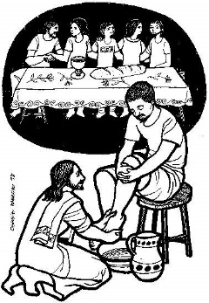the memorial acclamation is: When we eat this Bread…).

Here at 8pm, will have the Procession of the Holy Oils as part of the

entrance procession and also include rite of Washing of Feet, Renewal of Commitment

for Eucharistic Ministers and Readers, and Procession to Place of Repose.

**GOOD FRIDAY**

**Solemn Liturgy of the Passion of the Lord:** At 3 pm, with the reading of the Passion, Veneration of the Cross

(Parish Mass Book page 204) where you will have the choice of bowing or genuflecting, followed by

Communion.

At the end of the liturgy the entire congregation departs in silence.

A collection for the Holy Land shrines will take place.

Good Friday is a day of Fasting and Abstinence

The Church will remain open into the evening for private devotion.

**HOLY SATURDAY**

Today the Church waits at the Lord’s tomb, meditating on His Passion, death and descent into hell, awaiting in prayer and fasting His Resurrection.

Blessing of the Food (Święconka) will take place at 9am, 10am and 11am.

**Easter Vigil**  Weather permitting, the Easter Vigil of the Lord’s Resurrection

(Parish Mass Book page 219) begins at 8pm with all the people assembled outside the church for

Blessing of the Easter Fire and lighting of the candle. In Church, the

Vigil continues with the proclamation of the Exsultet and of Old and

New Testament readings, the Blessing of Water and renewal of

Baptism Promises.

**EASTER SUNDAY**

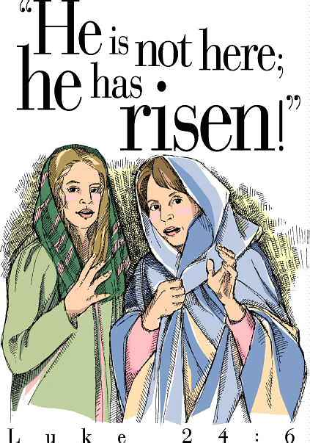

Mass at 10am.

**Please take home a copy of this Newsletter as it contains all the church celebrations for Holy Week, Triduum and Easter**