**ST PETER APOSTLE CHURCH, RUSHDEN**

Parish Priest: Rev Joe Walsh

Tel: 01933 353649

Deacon: Rev Peter Remmington

Parish Secretary: Charmaine: Tue to Thu: 10am - 2pm Parish Safeguarding Representative: Stuart Pearce

Email: [parish.stpeterrushden@northamptondiocese.org](mailto:parish.stpeterrushden@northamptondiocese.org)

Website: [https://rushdencatholicchurch.co.uk/](https://rushdencatholicchurch.co.uk/index.php/weekly-newsletter/)

Twitter:  [www.twitter.com/rushdencatholic](http://www.twitter.com/catholicrushden)

Facebook: [www.facebook.com/StPeterApostleRCChurchRushden](http://www.facebook.com/StPeterApostleRCChurchRushden)

**2nd APRIL 2023 – YEAR A**

**PALM SUNDAY - THE PASSION OF THE LORD**

**MASS BOOK:** Page 176 - 10am; Page 182 - 6:30pm

**PREFACE:** Page 73 The Passion of the Lord

**EUCHARISTIC PRAYER**: Number 2

**MYSTERY OF FAITH:** Save us, Saviour of the World…

**Sat:** 6:30pm - People of St Peter’s living & deceased

**Sun:** 10:00am - Clorindo Muccillo

**Tue:** 9:30am - Special Intention

**Wed:** 7:30pm - Lalljie - Bouttelisier

**Thu:** 8:00pm - Eileen Moore

**Fri:** 3:00pm - Solemn Liturgy of the Passion of the Lord

**Holy Saturday:** **Easter Vigil** 8:00pm - Special Intention

**Easter Sunday:** 10:00am - People of St Peter’s living & deceased

Sacrament of Reconciliation: Saturday 11am - 11:30am

Wednesday 8pm

Rosary: Wednesday 7:10pm

**Please pray for those whose anniversaries occur at this time:** Martha Robson, Stanley Hawkins, Mychayl Karpjuk, Livia Iacobucci, Pura Caamano, Angela Clifford, Fanny Hazell, Julia Richardson, Helen Morgan, James Scully, Lucy McDonough, Albert Murphy, Rose Ahern, Reginald Jacobs, Nestor Komarnycky and Mary Denton.

**People who need our prayers:** Jacob, Peter & Paul, Frank, Val, Neal, Yvonne, Kele, Sam Sophie, Lewis the Bailey & Thompson families, Melissa, Josie & family, Josh & family, Eileen, Marie, Andrew, Christophe, Leanne, Timothy, Sandrine & family, Eileen, Jayne, the Collett family, Wendy, Rita, Achu, Daw, James, David, the Donnelly & Peachey families, Erykah, Everlyn, the Allen family, Liz, Merin, Edwin, Isabell, Albin, Katherine, Rowan and Karra.

**OFFERTORY:** Last week’s collection amounted to £444.91. Thank you very much.

**EASTER CLERGY COLLECTION:** Will be taken next weekend at both Masses.

**PALM SUNDAY:** Today, after the Passion readings are proclaimed, a time of silence will follow.

**RENEWAL OF COMMITMENT:** For Eucharistic Ministers and Readers will take place on Holy Thursday. It is necessary to attend in order to proclaim the Word and for administering the Holy Eucharist.

**TIME TOGETHER GROUP:** Meets next Saturday, April 8th, at 2:30pm in the Parish Hall, when Keith Fossey will tell us about school projects in Swaziland (now Eswatini). All are welcome.

**FOODBANK DONATIONS:** There is a comprehensive list of requested items at the back of Church (including tinned foods & household goods). Please keep the donations coming, as stocks are running low and demand is increasing more and more. Thanks to everyone for all the donations, both of goods and money!

**CHILDRENS’ LITURGY:** Dear parishioners, please let me know if you would be interested to help us deliver the childrens’ liturgy for ages 5-8 years at the 10am Mass on Sundays during term time. We hope to engage enough people so that each pair will only need to do one Sunday every half term. There will be resources, information and support made available. Kindly ring or text Monica on 07707 034112 for more information.

**RECENT DEATHS:** The death has occurred of Faye Jeanette Samples fortified by the prayers of the church. Her funeral prayers will take place on Tuesday April 11th at 11am.

Your prayers are requested for the repose of the soul of Fr Richard Smith whose funeral will be at the Catholic Church in Kettering on April 12th at 11am with a burial afterwards.

GIFT AID ENVELOPES: Existing donors, please pick up your new box of envelopes from the back of church. Any new donors (tax payers) are always welcome. You can donate any amount whenever you like and it is all in complete confidence. Please call in to the Parish Office if you are interested.

**GOOD FRIDAY OPEN AIR SERVICE:** By Churches Together this year will be at 11:30am on the lawn of St Mary’s Church, Rushden; tea, coffee and refreshments will be served in St Mary’s Church Hall at 11am before the ceremony begins.

**GOOD FRIDAY:** Is a day of Fasting and Abstinence.

At the 3pm Solemn Liturgy of the Passion of the Lord, including the usual procession to venerate the Cross where you will have the choice of bowing or genuflecting.

**THE EASTER VIGIL:** Please be careful when holding your lit candle not to allow the hot wax drip outside the plate and onto the carpet.

**HOLY WEEK / EASTER TRIDUUM**

On **Palm Sunday of The Lord’s Passion** this Sunday at the 10am Mass the palms will be blessed. We meet in the Parish Hall first then move to the church where we process afterwards.

On **Maundy Thursday** There will be Chrism Mass at the Cathedral at 11am. The Evening Mass of The Lord’s Supper will be held here at 8pm.

On **Good Friday** the Solemn Liturgy of the Passion of The Lord is at 3pm with Stations of the Cross at 9am. The Church will be open all day.

On **Holy Saturday** the Easter Vigil of the Lord’s Resurrection will be at 8pm.

On **Easter Sunday** Mass will be at 10am.

**THE DIVINE MERCY NOVENA:** Starts on Good Friday, and the Divine Mercy Service will be held on the Second Sunday after Easter (April 16th) at 3pm in Church.

**SACRAMENT OF RECONCILIATION:** Before Easter will be celebrated at 7:30pm Mass on Wednesday April 5th and Saturday April 8th. It will also be celebrated on Divine Mercy Sunday, April 16th.

**ADORATION:** Tuesday: 10:15am to 6pm.



**SACRAMENT OF RECONCILIATION:** Before Easter will be available after the 7:30pm Mass on Wednesday April 5th and from 11am to 11:30am on Saturday April 8th. *(Obligation on penitents to fulfil their Easter duties for this Sacrament has franchise up to Trinity Sunday, June 4th.)*

**MAUNDY THURSDAY**

**Chrism Mass:** Bishop David invites all to the Diocesan Chrism Mass on Maundy Thursday at the Cathedral at 11am.

**Mass of the Lord’s Supper:** (Parish Mass Book page 192; Eucharistic Prayer 1 includes the prayers on pages 19/21 and

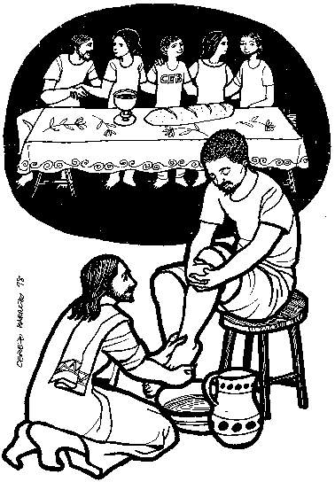 the memorial acclamation is: When we eat this Bread…).

Here at 8pm, will have the Procession of the Holy Oils as part of the

entrance procession and also include rite of Washing of Feet, Renewal of

Commitment for Eucharistic Ministers and Readers and Procession to Place of Repose.

A time of Watching with the Lord follows the Mass at the Place of Repose.

**GOOD FRIDAY**

**Stations of the Cross:** All are welcome to attend Stations of the Cross at 9am.

**GOOD FRIDAY OPEN AIR SERVICE:** By Churches Together this year will be at 11:30am on the lawn of St Mary’s Church, Rushden, tea, coffee and refreshments in St Mary’s Church Hall at 11am before the ceremony begins.

**Solemn Liturgy of the Passion of the Lord:** At 3 pm, with the reading of the Passion and Veneration (Parish Mass Book page 197) of the Cross where you will have the choice of bowing

or genuflecting. At the end of the liturgy the entire

congregation departs in silence.

A collection for the Holy Land shrines will take place.

Good Friday is a day of Fasting and Abstinence

The church will remain open into the evening for private devotion.

**HOLY SATURDAY**

Today the church waits at the Lord’s tomb, meditating on His Passion, death and descent into hell, awaiting in prayer and fasting His Resurrection.

**Easter Vigil:** Weather permitting, the Easter Vigil of the Lord’s Resurrection

(Parish Mass Book page 216) begins at 8pm with all the people assembled outside the church for

blessing of the Easter Fire and lighting of the candle. In church, the

Vigil continues with the proclamation of the Exsultet and of Old and

New Testament readings, the Blessing of Water and renewal of

Baptism Promises.

**EASTER SUNDAY**

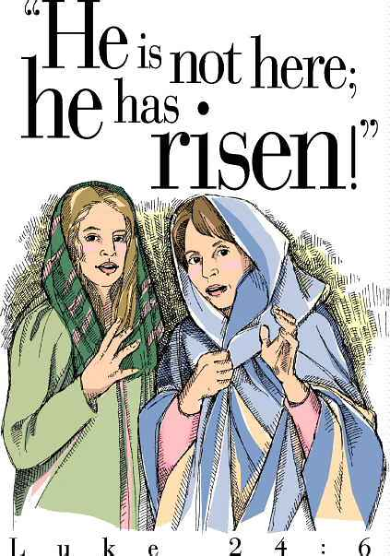

Mass at 10am.

**Please take home a copy of this Newsletter as it contains all the church celebrations for Holy Week, Triduum and Easter**