**ST PETER APOSTLE CHURCH, RUSHDEN**

Parish Priest: Rev Joe Walsh

Tel: 01933 353649

Deacon: Rev Peter Remmington

Parish Secretary: Charmaine: Tue to Thu: 10am - 2pm

Email: [parish.stpeterrushden@northamptondiocese.org](mailto:parish.stpeterrushden@northamptondiocese.org)

Website: [https://rushdencatholicchurch.co.uk/](https://rushdencatholicchurch.co.uk/index.php/weekly-newsletter/)

Twitter:  [www.twitter.com/rushdencatholic](http://www.twitter.com/catholicrushden)

Facebook: [www.facebook.com/StPeterApostleRCChurchRushden](http://www.facebook.com/StPeterApostleRCChurchRushden)

**18th DECEMBER 2022 – YEAR A**

**FOURTH SUNDAY OF ADVENT**

**MASS BOOK:** Page 90

**PREFACE:** Page 66 Preface II of Advent

**EUCHARISTIC PRAYER**: Number 2

**MYSTERY OF FAITH:** When we eat this Bread…

**Sat:** 6:30pm - People of St Peter’s living & deceased

**Sun:** 10:00am - Eleanor Murray

**Tue:** 9:30am - Jean Arthur - Intention

**Wed:** 7:30pm - Rose Vakanil

**Thu:** 9:30am - Lily & John Riddle

**Fri:** 7:30pm - Bob Coton

**Sat:** **Christmas Eve**

6:00pm - Carols

6:30pm - Vigil Mass for Christmas - Henriette Judge 11:30pm - Carols

12:00 Midnight Mass - Special Intention

**Sun:** **Christmas Day**

10:00am - People of St Peter’s living & deceased

Sacrament of Reconciliation: Saturday 11am - 11:30am

Rosary: Wednesday 7:10pm

**Please pray for those whose anniversaries occur at this time:** Margaret Ward, Mariola Hejna, Peter Barnet, Clare Shaw, George Sutton, Barbara Robson, Urszula Solujan, Mary Lynam, Hannah Way, Sheila Gilholme.

**People who need our prayers**

Bill H, Patsy, Sophie, Neil & family, Ida and Roberto, Bernie, the Mutiswa family, Terry M and, Christopher & Edith, Jason & Naomi and Faye, Merin, Serine, Katherine, James, Dan, Anne, Anna, Austin, Jenny, Nora, Laura and her children and husband, Eva, Bill P, the Collett family, Wendy, Helena, Kevin B and the Schiff & Abels family.

**OFFERTORY:** Last week’s collection amounted to £484.08. Thank you.

**TEA/COFFEE/REFRESHMENTS:** After Sunday’s Mass will be in the Parish Hall.

**FOODBANK DONATIONS:** There is a comprehensive list of requested items at the back of church; for example tinned meat & fish, peas and carrots, jam, coffee, shampoo - please see list. **No other items** please are at present required.

**WALKING BY STARLIGHT: ONLINE ADVENT RETREAT:** Thursday December 22nd at 7.30pm or any time afterwards.

Week 4: courage. Having explored attentiveness, wonder and trust, we now move to the final characteristic of the Magi – courage. Take time in the busiest week of the year to spend an hour of Advent reflection. Find all previous episodes and sign up here: <https://pastoralministryoffice.org/walking_by_starlight-2/>

**DECORATING THE CHURCH FOR CHRISTMAS:** Will be on Tuesday December 20th at 10:15am. All offers of help welcomed.

**CHRISTMAS CARDS:** There is a box at the back of church for Christmas cards. Please check to see if any are for you.

**Seeing your Life through the Lens of the Gospel**

1. It took some for Joseph to accept the fact that, in Mary, there truly was Emmanuel - God with us. God is with us now, but at times we struggle to perceive God’s presence. *Where have you unexpectedly discovered the presence of God with you? Recall those experiences and give thanks.*

2. Joseph was confused and uncertain about what he should do. It took time, and outside help, for him to discern what his next step should be. Perhaps you have also had difficulties along the way to some decisions or commitments*. Recall that journey and the moments when it became clear to you what was being asked of you.* *Give thanks for the angels who helped you along the way.*

3. Mary bore Jesus within her, unseen to all, and unacknowledged by most. In Joseph she found one who believed in the treasure that she bore. We can be bearers of Jesus to others and they to us. *When have you been that kind of a bearer of Jesus to another? Who has been that to you?*

**ADORATION:** Tuesday from 10:15am to 6pm.

**At the Creed during all Christmas Masses** *all kneel* at the words “and by the Holy Spirit was incarnate.”

**New Donation Station**

You will find our new DIGITAL COLLECTION PLATE, contactless terminal as you enter the Church. Just use your contactless debit/credit card or smart phone/ device to make a donation.

Simply choose the amount you wish to donate and hold your card onto the reader.

You can also opt-in for Gift Aid to increase your donation by 25%.

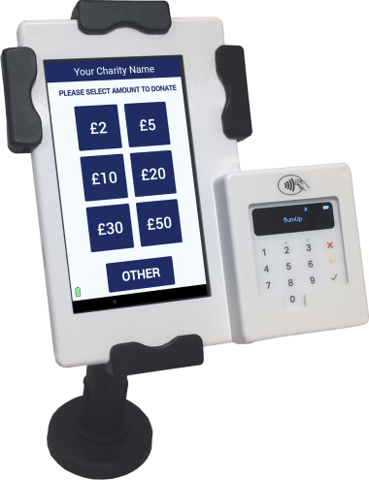If you are a UK taxpayer then donating with Gift Aid means that we can claim an extra 25p for every £1 received. If you give via Gift Aid, you only have to register your details once, as you will be recognised for future donations.