**ST PETER APOSTLE CHURCH, RUSHDEN**

Parish Priest: Rev Joe Walsh

Tel: 01933 353649

Deacon: Rev Peter Remmington

Parish Secretary: Charmaine: Tue to Thu: 10am - 2pm

Email: [parish.stpeterrushden@northamptondiocese.org](mailto:parish.stpeterrushden@northamptondiocese.org)

Website: [https://rushdencatholicchurch.co.uk/](https://rushdencatholicchurch.co.uk/index.php/weekly-newsletter/)

Twitter:  [www.twitter.com/rushdencatholic](http://www.twitter.com/catholicrushden)

Facebook: [www.facebook.com/StPeterApostleRCChurchRushden](http://www.facebook.com/StPeterApostleRCChurchRushden)

**PALM SUNDAY - THE PASSION OF THE LORD**

**10th April 2022 – YEAR C**

**MASS BOOK:** Vigil: Page 190

Morning: Page 184

**PREFACE:** Page 73 The Passion of the Lord

**EUCHARISTIC PRAYER**: Page 18 Number 1

**MYSTERY OF FAITH:** Save us, Saviour of the World…

**Sat:** 6:30pm - Lucia Indolo

**Sun:** 10:00am - The People of St Peter’s

living & deceased

**Tue:** 9:30am - Sheila Lynn

**Wed:** 7:30pm - Zelinda Muccillo

**Thu:** 8:00pm - Ciders Bridget McDonagh

**Fri:** 3:00pm - Solemn Liturgy of The Passion of the Lord

**Sat:** 8:00pm - Biagio Campanaro

**Sun:** 10:00am - The People of St Peter’s

living & deceased

Sacrament of Reconciliation: Wednesday 8pm

Rosary: Wednesday 7:10pm

**Please pray for those whose anniversaries occur at this time:** Margaret Batchelor, Maureen Morphett, Margaret Fischer, Patrick Connell, Edie Broadbent, John Downes, Mario Fratangelo, Connor Evans, Geoge Osborne, Doris Hopwood, Jane & Eric Turner, Brigid Crean, Margaret Caracchia, Jennifer Wheeler, Zelinda Muccillo, Elizabeth Irwin, Paula Freeman, Jacoba Richards, Michael Harris, Jan Kala, Patrick Walsh, Antonio Girardi, Eva Cummings, Charles Ward and Antonio Leto.

**Please remember in Prayer**

Mark Dowling, June Dowling, Kevin B, Susan, Andrew, Patricia (Pat) S, Janet O’L.

**OFFERTORY:** Last week’s collection amounted to £532.35. Thank you very much.

**MISSIO:** Thanks all those who responded to the Missionary priests appeal. Red boxes in need of counting should be returned to back of church. Named boxes will receive a receipt. Thank you.

**EASTER CLERGY COLLECTION:** Will be taken next weekend at both Masses.

**PALM SUNDAY:** Today, after the Passion readings are proclaimed, a time of silence will follow.

**IMPORTANT NOTICE**

With the lifting of all legally required Coronavirus restrictions by the government, Fr Joe and Deacon Peter ask that you continue to wear face coverings when coming to Mass and in all our church buildings please, unless for medical reasons you are unable to do so. The measures that are now in place within the church will remain in place for now, so please continue to act carefully and exercise personal judgement to manage your own risk and be sensitive to the concerns of others.

**FOODBANK DONATIONS:** There is a comprehensive list of requested items at the back of church for example tinned meat & fish, peas and carrots, jam, coffee, shampoo please see list. **No other items** please are at present required. Thank you for your kind donations.

**UNION OF CATHOLIC MOTHERS:** Our next meeting will be on TUESDAY April 19th at 12.30pm in the Lounge. Please bring your own lunch.

**LENTEN PRAYER MEETING:** Wednesday, April 13th from 12noon-1pm. No lunch, Zoom only; Stations of the Cross to be led by our parish from 12:30pm to 1pm. [https://us02web.zoom.us/j/83179978325?pwd=NXZyeWxxNzhHWVV0bEJEZ3E4YjkwUT09](https://us02web.zoom.us/j/83179978325?pwd=NXZyeWxxNzhHWVV0bEJEZ3E4YjkwUT09" \t "_blank)

Meeting ID: 831 7997 8325 Passcode: lentprayer

Link on WhatsApp Rushden Catholics

GIFT AID ENVELOPES: Existing donors, please pick up your new box of envelopes from the back of church. Any new donors (tax payers) are always welcome. You can donate any amount whenever you like and it is all in complete confidence. If you are interested, please call in to the Parish Office.

**RENEWAL OF COMMITMENT:** For Eucharistic Ministers and Readers will take place on Holy Thursday. It is necessary to attend in order to proclaim the Word and for administering the Holy Eucharist.

**GOOD FRIDAY OPEN AIR SERVICE:** By Churches Together this year will be at 11am on the lawn of St Mary’s Church, Rushden.

**GOOD FRIDAY:** Is a day of Fasting and Abstinence.

At the 3pm Solemn Liturgy of the Passion of the Lord, the usual procession to venerate the Cross will be reinstated and you will have the choice of bowing or genuflecting.

**THE EASTER VIGIL:** Please be careful when holding your lit candle not to allow the hot wax drip outside the plate and onto the carpet.

**HOLY WEEK / EASTER TRIDUUM**

On **Maundy Thursday** There will be Chrism Mass at the Cathedral at 11am. If anyone is planning on coming to this year’s Chrism Mass and would like to stay for lunch let Deacon Peter know as soon as possible, by the evening of Monday 11th April at the latest please because numbers are limited.

The Evening Mass of The Lord’s Supper will be held here at 8pm.

On **Good Friday** the Solemn Liturgy of the Passion of The Lord is at 3pm with Stations of the Cross at 9am. The Church will be open all day.

On **Holy Saturday** the Easter Vigil of the Lord’s Resurrection will be at 8pm.

On **Easter Sunday** Mass will be at 10am.

**THE DIVINE MERCY NOVENA:** Starts on Good Friday. Prayer pamphlets will be handed out on Palm Sunday and the Divine Mercy Service will be held on the second Sunday after Easter (May 1st) at 3pm in Church.

**CAN YOU HELP? If anyone is interested in hosting a Ukrainian family or would like to know more about how you can help, please get in touch with the Caritas office by phone on 01604 434362 or at:** [caritas@northamptondiocese.org](mailto:caritas@northamptondiocese.org). Deacon Jim at Caritas can then begin to build a list of possible hosts and support groups in readiness. On behalf of all Ukrainian refugees thank you.

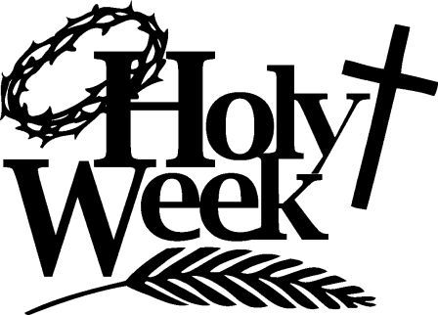

**WEDNESDAY**

Sacrament of reconciliation is available after the 7:30 pm Mass.

**MAUNDY THURSDAY**

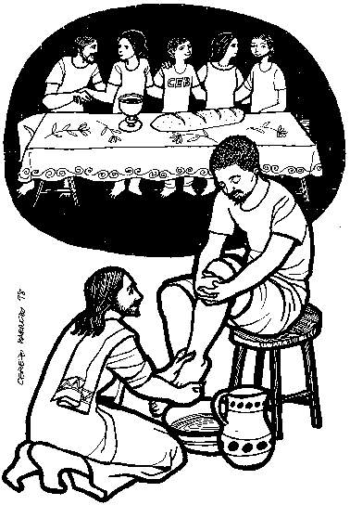**Chrism Mass:** Bishop Peter invites all to this Diocesan Mass on Maundy Thursday at the Cathedral at 11 am. If you are planning on coming to this year’s Chrism Mass and would like to stay for lunch let Deacon Peter know as soon as possible, by the evening of Monday 11th April at the latest please because numbers are limited.

**Mass of the Lord’s Supper:** (Parish Mass Book page 199; Eucharistic Prayer 1 includes the prayers on pages 20/21 and

the memorial acclamation is: When we eat this Bread…).

Here at 8pm, will have the Procession of the Holy Oils as part of the

entrance procession and also include rite of Washing of Feet, Renewal of

Commitment for Eucharistic Ministers and Readers and Procession to Place of Repose.

A time of Watching with the Lord follows the Mass at the Place of Repose.

**GOOD FRIDAY**

**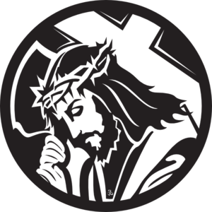Stations of the Cross:** All are welcome to attend Stations of the Cross at 9 am

**March of Witness:** Leaving The Salvation Army Hall at 10.45am followed by Open-Air service outside Wesleyan Church, High Street.

**Solemn Liturgy of the Passion of the Lord:** At 3 pm, with the reading of the Passion and Veneration (Parish Mass Book page 204) of the Cross where you will have the choice of bowing

or genuflecting. At the end of the liturgy the entire

congregation departs in silence.

A collection for the Holy Land shrines will take place.

Good Friday is a day of Fasting and Abstinence

The church will remain open into the evening for private devotion.

**HOLY SATURDAY**

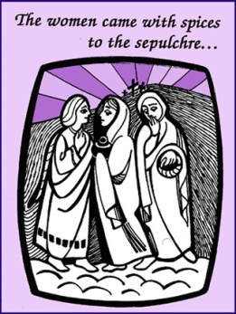

Today the church waits at the Lord’s tomb, meditating on His Passion, death and descent into hell, awaiting in prayer and fasting His Resurrection.

**Easter Vigil:** Weather permitting, the Easter Vigil of the Lord’s Resurrection

(Parish Mass Book page 223) begins at 8pm with all the people assembled outside the church for

blessing of the Easter Fire and lighting of the candle. In church, the

Vigil continues with the proclamation of the Exsultet and of Old and

New Testament readings, the Blessing of Water and renewal of

Baptism Promises.

**EASTER SUNDAY**

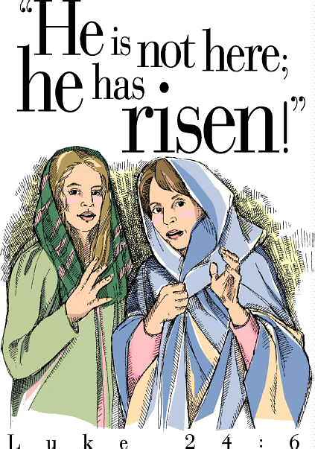

Mass at 10am.

**Please take home a copy of this Newsletter as it contains all the church celebrations for Holy Week, Triduum and Easter**